Cambridge University

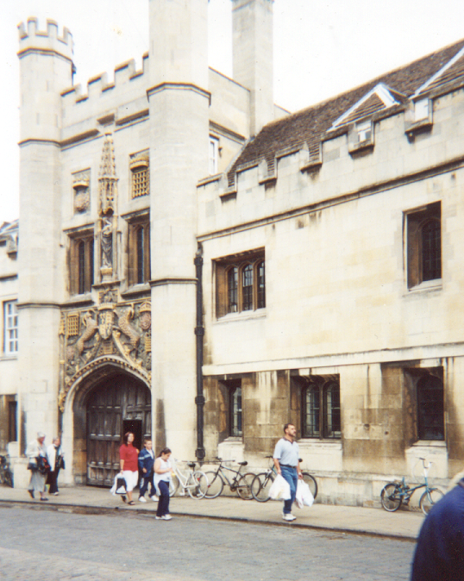
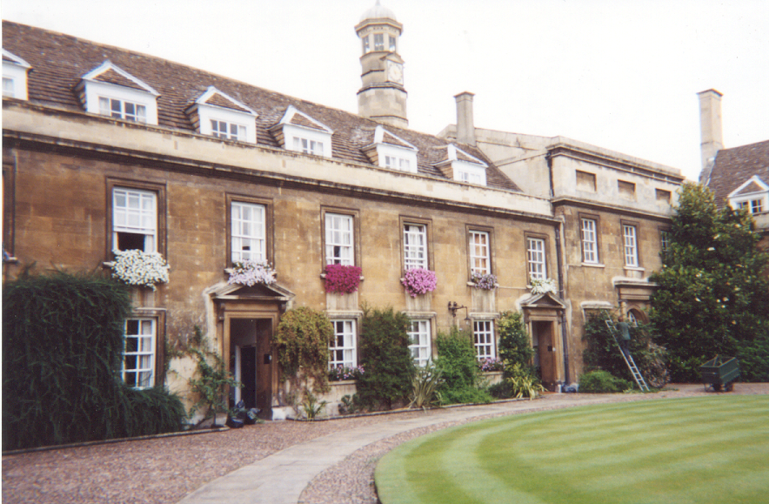
At age 19 Charles was enrolled at Christ’s College, Cambridge Figs--- to become a clergyman in the Anglican Church. His disappointed father saw this as a necessity because Charles had been unwilling to complete his studies at Edinburgh and enter the traditional family profession as a physician. He arrived at Cambridge in January 1828. To go to either Cambridge or Oxford was to enter the world of the Victorian Gentlemen and to hobnob with the elite and ruling classes of England. Both the Darwin’s and the Wedgwood’s were prominent country gentlemen and Charles found Cambridge rather suited his taste. His father provided him with a very adequate allowance of 200 lbs a year. Charles soon felt more at home at Cambridge where he became reacquainted with past friends from both Reverend Case’s school as well as from Dr. Butler’s school, in Shrewsbury. Of even more significant however, he found a cousin there by the name of William Darwin Fox who would become a close, life-long friend. As young men they were much the same in temperament and liked to be in each other’s company. Later in life they would comfort each other in times of severe tragedy, particularly when they had members of their immediate family die. Another cousin from the Wedgwood side of the family and a good friend of his brother Erasmus (Ras) -- Hensleigh Wedgwood, was also at Christ’s College when Charles arrived and, they too, would maintain lifelong friendships

It was Fox who introduced Charles to beetles and the two of them spent many hours in pursuit of rare beetles -- entomology united them! In Charles’s own words “no pursuit was followed with nearly so much eagerness or gave me more pleasure as collecting beetles.” At this time he also subscribed to a natural history periodical on entomological work published by James Stephens. Darwin established contact with Stephens and sent him a number of beetles and a moth, as a result his name appear in the publication. He took pleasure in telling Fox that “you will see my name in Stephen’s last number.” The challenge of catching rare beetles was particularly rewarding and Darwin recalls this interesting experience “one day on tearing off some old bark, I saw two rare beetles and seized one in each hand; then I saw a third and new kind, which I could not bear to lose, so that I popped the one I held in my right hand into my mouth. Alas it ejected some acrid fluid, which burnt my tongue so that I was forced to spit the beetle out, which was lost as well as the third one.” There is no doubt that he was a natural born entomologist as he quipped “it is quite absurd how interested I am getting to be about the science.”

Unlike the more secular universities like Edinburgh or University College London (known as the Godless College), Oxford and Cambridge were mainly theological training schools for the Anglican Church and had been an integral part of the church since Henry the VIII. Darwin accepted the idea of becoming a member of the Clergy and he envisioned himself in a parish church with plenty of time to participate in activities involving his interest in natural history. It is clear that Charles’s enthusiasm for the natural sciences, first exhibited while he was in Edinburgh became even more central to his interests at Cambridge. He and his close friend Fox, read William Paley’s book on Natural Theology which suggested that the way of understanding the natural world was to see it as evidence of God’s creative powers. However, in 1830, Charles read John Hershel’s Preliminary Discourse on the Study of Natural Philosophy that gave an expansive view of the future of scientific understanding and as a result, he developed a burning desire to add his own contribution to the “noble structure of natural sciences.”

Professor John Stevens Henslow, from whom Charles took a course in botany, befriended him, as Henslow recognized Darwin’s promise as a naturalist. He also encouraged Charles to take a course in geology as he thought it would be valuable to his future studies. Charles had already developed an interest in geology, but Professor Adam Sedgwick’s lectures on the subject, gave him a greatly expanded appreciation for the time-line that was available for the development of biological systems.

After Charles completed his degree at Cambridge in 1831 he and Adam Sedgwick spent some time working on a geological map and studying rock formations in northern Wales. When they returned to Shrewsbury two letters were waiting for Charles, one was from Professor Henslow and the other from George Peacock. Who was responsible for nominating naturalists navy ships making surveys. Henslow had recommended Darwin to Peacock, who was offering the post of unpaid naturalist to go on a trip around the world on the HMS Beagle. All this was a complete surprise to Charles who did not consider himself qualified as a naturalist but was eager to accept. Robert Darwin thought it was a wild scheme but did not absolutely forbid Charles from going but said “if you can find any man of common sense who advises you to go, I will give my consent.” Reluctantly Charles wrote to Henslow saying that he could not go. He immediately left to go on a hunting trip with his uncle Josiah Wedgwood II. Uncle Jos did not agree with Charles’s father and thought that the offer to go on the Beagle was too important to turn down. He returned immediately with Charles to Shrewsbury to convince Robert, his brother-in-law that it would be a great experience for Charles. It is important to know that Robert had always regarded Josiah as a man of reliable common sense. After a discussion among the there of them Robert gave his consent for Charles to go on the voyage that would eventually change his life. Charles, in a great state of excitement wrote a letter to Henslow canceling his earlier letter of refusal. The following morning he took a coach to Cambridge to see Henslow. Henslow had bad news for him and told Darwin that an offer had been made to a Mr. Chester, all was not lost as yet, because the Captain of the Beagle Robert Fitzroy, had made it clear that he would only take someone whom he liked personally as they would be sharing a cabin that was very small. As it turned out after two meetings; the Captain chose Charles. On learning that he had been selected Charles wrote a very prescience letter to Fitzroy saying that, “the day of the Beagle’s departure would be glorious. My second life will begin and it shall be as a birthday for the rest of my life.”

