Edinburgh University

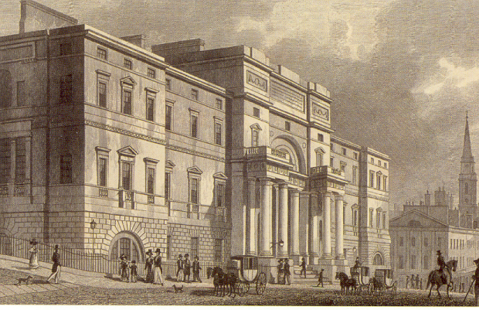
At the tender age of sixteen, Charles was enrolled at Edinburgh University by his father Robert to study medicine and fallow in the footsteps of both his grandfather Erasmus Darwin and his father Robert as a physician. To prepare Charles for Edinburgh, Dr. Robert Darwin had spent considerable time with Charles the previous summer, taking him on visits to his patients at the hospital and teaching him the skills he used as a physician. Charles was enthusiastic about what he was learning and Dr. Darwin concluded, that Charles would make a very fine physician. We should also note perhaps, that the connection with Edinburgh was an important one for the Darwin’s because both his father and paternal grandfather, Erasmus Darwin, spent time there. At that time, Edinburgh had gained an equal footing with Leiden, in Holland (the medical school where Robert received most of his training) and Padua in Italy -- as eminent medical schools and in addition, during the mid 1700s, Edinburgh was the center of the Scottish enlightenment with David Hume as a resident philosopher. Nevertheless, Charles could neither stand the sight of blood nor the practice of performing amputations without an anesthetic and refused to complete his studies. In general he found the classes required for medical practice uninteresting although he did enjoy a return to his early interest in chemistry, an interest that he and his older brother Ras had shared in a ‘lab’ they had put together in the family garden tool shed, which was taught by Professor Thomas Hope.

While at Edinburgh in 1826 and early 1827 Charles forged an important friendship with professor Robert Grant who taught Zoology and they would take walks along the Firth of Forth collecting specimens. Grant taught him to do dissections and to make detailed observations under a microscope. It was also from Grant that he learned about the French naturalist Lamarck and his ideas about transmutation. Interestingly, Erasmus Darwin Charles’s grandfather, and Jean Baptiste Lamarck were contemporaries and whereas Erasmus was referred to as the English Lamarck – Lamarck was referred to as, the Parisian Darwin. Both men, where avid proponents of the principle of transmutation, a term, later replaced with, evolution. Grant’s interest in both Lamarck and particularly in the work of Erasmus Darwin spurred Charles’s interest in the writings of both men. And it was at this time that he read Lamarck’s systeme des animaux sans vertebresand and studied his grandfather’s extensive work entitled Zoonomia. He thus thoroughly acquainted himself with their views on the principles of transmutation or evolution, the subject that would eventually consume his interest for most of his life.

While at Edinburgh Charles appeared to learn more from his informal activities than he did in the classroom. He pursued his interest in natural history by frequent visits to the Museum where Mr. William MacGillivrary was the curator. They also became friends, and MacGillivary taught him about the anatomy of animals and some botany and how to take notes on the observations he made. It was through another friend, John Edmonstone, that Darwin learned the art of taxidermy. John was a freed slave from Guyana and while they worked they talked about the rain forests of South America that inspired Darwin and influents his decision to go around the world on the Beagle.

On trips home to Shrewsbury while he was a student at Edinburgh, Darwin made extended forays into northern Wales where he used a book by Gilbert White, entitled "The Natural History of Selborne" as a guide to developing an interest in the beauty of birds and insects. It was at this point in his life that he began to keep his own field notebook and to record detailed observations on the subject of his studies.

It is obvious that Charles Darwin was becoming a self trained Naturalist with a keen interest in basic science even though he was only seventeen or eighteen years of age. It was no surprise then when, that he started to attend the science club known as the Plinian Society that emphasized studies of the natural world instead of the idea of supernaturalism. Darwin's very first talk was given to this group on the 27th of March 1827, on the marine biology of the Firth of Forth.

Even though his father did not appreciate it, his son was developing the skills he would need for his lifelong work -- largely on his own, outside the confinement of the classrooms at Edinburgh. He was destine to become the most respected and remembered naturalist of the 19th Century.

