Shrewsbury: Birthplace and Childhood -- 1809 to 1825.

Charles Robert Darwin was born in the town of Shrewsbury, England on February 12th 1809 and this picturesque, well-maintained Medieval town is much the same today as it would have been in Darwin's time. The old town is almost completely surrounded by a horseshoe-shaped bend in the River Severn, as shown in this Arial view of the town below, Fig 1. The English Bridge is to the lower right and the Kingsland Bridge is to the left while the Welsh Bridge is at the center-top of this photograph. In addition there are also foot bridges across the river at several points.
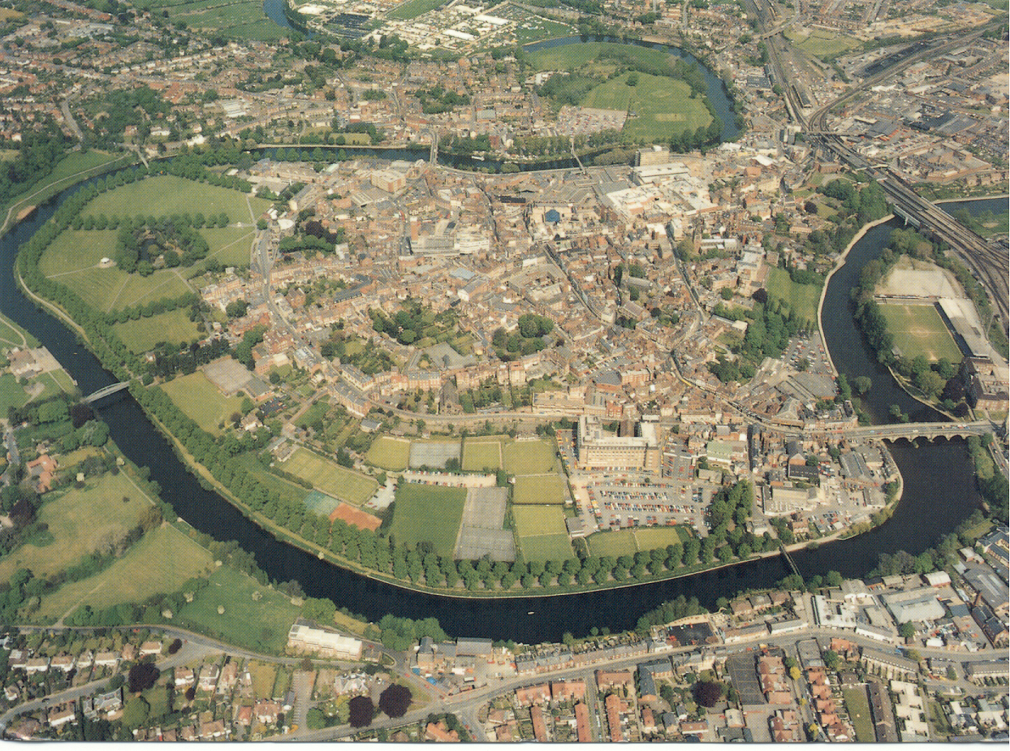
Figure 1. An Aerial Photograph of Shrewsbury looking north

The only home that Charles Darwin knew from the time he was born until he returned from his five-year trip around the world on the Beagle at he age of 29, was his family home right here in Shrewsbury. In chronological order, here are the places in Shrewsbury that were important in Darwin's life and that we will visit in greater detail below. Darwin's Family Home, known as The Mount House is situated on a bluff overlooking the River, is located at the top, center-left (A). On November the 15th 1809, the same year as he was born Charles was baptized in Saint Chad's Anglican Church (B) however, as a young child his mother, the former Susannah Wedgwood, who was a Unitarian took him with her to the Unitarian Church at ---- High Street, near the center of town (C). Reverend, Case was the minister of the church and also ran an elementary School at 13 Claremont Hill (D), which is close to St. Chad's Church. At the age of eight, Charles was enrolled in Rev. Case's school by his mother but attended this school for only one year.
Unfortunately during this year his mother died and he was enrolled at Doctor Samuel Butler's school (E) also known as the Shrewsbury School.

At age 16 his father Robert enrolled him at Edinburgh University and while Charles would return to the family home as a college student and also returned here after his five-year voyage around the world; he never lived here permanently again after leaving for Edinburgh.

Other familiar places in Shrewsbury that would have been familiar to Darwin are the Train Station (F), the Shrewsbury Castle (G), and Shrewsbury Abby just off the English Bridge to the right, beyond the edge of the photo. Two additional place that deserved to be mentioned even though they had not been built in Darwin's time -- are the New Shrewsbury secondary school across the Kingsland Bridge and up the hill overlooking the River Severn from the South (H) and the ‘Darwin’ Shopping Center (I) in the middle of town. The campus at the new secondary school is attractive, consisting of a number of handsome redbrick buildings. The reason for mentioning it however is that there is a large statue of Darwin on campus in front of the Administration building. He is depicted as an energetic and active young man on the Galapagos Islands, with iguanas and other creatures around his feet. The Shopping Center is large and modern – an asset to the town and recognizes there most famous son!

