Draft 5/20/04

The Galapagos and the Voyage of the Beagle

Charles Darwin’s discoveries of unique flora and fauna in the Galapagos Islands are widely mentioned as being the source of his inspiration about evolution: descent with modification. It would be more accurate to say that what he found in the Galapagos only confirmed the explanation he had been formulating for the previous three years of the Beagle’s voyage, during which he had the opportunity to view a multitude of amazing animals, plants, and land formations. It is also commonly believed that he spent a long time in the Galapagos collecting samples. In fact, his time sailing in and around the islands was a mere 5 weeks: Sept. 17 – Oct. 20, 1835. Whenever the Beagle reached an interesting point that was navigable, the ship dropped off a boatload of men to explore. Darwin spent only 17 days onshore gathering specimens of birds, animals, insects, plants, rocks, and fish.

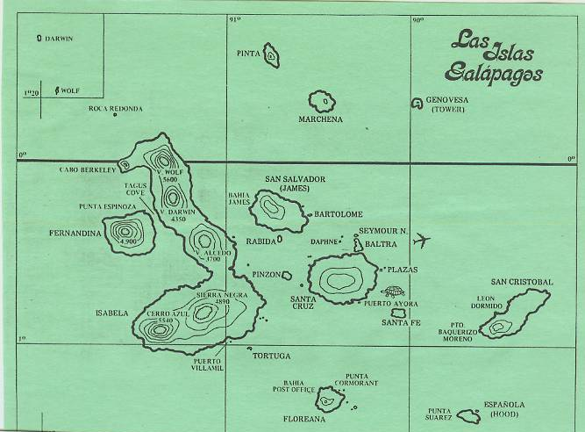

To provide a bit of background to Darwin’s arrival, the Galapagos are a group of twelve small volcanic islands located on the equator 500 miles off the coast of Equador. They were discovered by a Panamanian Bishop in 1535. In Spanish, the word for giant tortoise is “Galapago.” They are also referred to as “Las Encantadas” meaning the enchanted islands, in acknowledgement of the amazing creatures that reside there. In the 1800s they were, as now, owned by Equador. In Darwin’s time, the Galapagos were considered a refueling and refreshment stop for a fleet of 60-70 American whaling vessels. The endemic giant tortoises provided ships with an easy-to-catch source of fresh meat that stayed alive onboard ship for months while requiring very little maintenance.

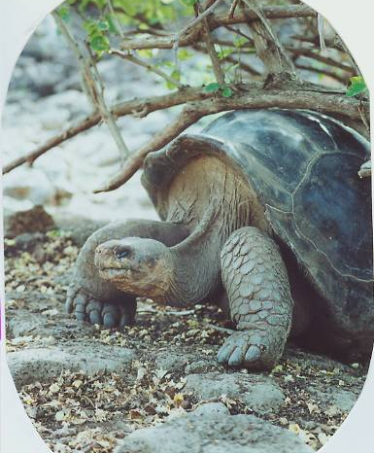
When Darwin arrived, the Beagle had been at sea for over three and a half years. Leaving Devon, England on Dec. 27 1831, the ship made its way south through the Atlantic, stopping at the Canary and Cape Verde Islands before reaching the coast of Brazil at Bahia on February 28, 1832. It then spent the next 3 years hugging the coastline of South America, performing the cartography, charting, and depth measurements that were the missions assigned to her by the British Royal Navy. An additional mission was to identify a more accurate way of determining longitude.

Darwin spent much of his time in South America on land excursions. He would disembark at one port of call and rejoin the Beagle at its next landing. On these treks he viewed incredible things that could not be explained by the scientific and religious belief systems of his time. The discoveries he made not only challenged current dogma in biology, botany, zoology and theology, they also held a huge impact to the emerging discipline of geology. In his book The Voyage of the Beagle Darwin writes of his delight and amazement at discovering such oddities as fossils of sea shells and fish on exposed cliffs 12,000 feet up in the Andes. He found living animals and fossil remains where the structure of a species remained constant (e.g. armadillos with their curved, segmented shells) but in sizes ranging from a under a foot long to over 20 feet long depending on the habitat. Darwin wrote of seeing living rheas and guanacos as well as their fossilized remains, noting that they represented a variety of sizes and colors. While similar enough to be classified as rheas and guanacos, each new group he encountered had something unique that made them just a bit different. He began to note the usefulness of these differences to the animals in terms of their success at defending their territory and obtaining food or mates.
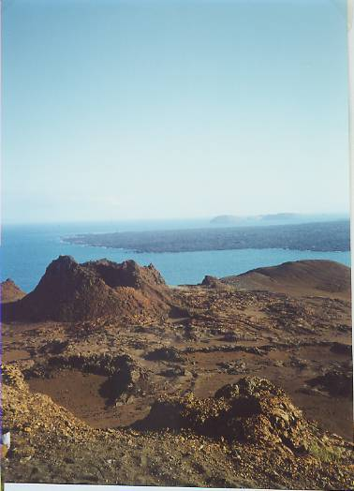
With these discoveries in mind and having spent many months striving to formulate a mechanism that might explain them, Darwin and the Beagle landed in the Galapagos. There he discovered barren, inhospitable, hot, dry volcanic islands that were, quite to his amazement, sustaining a multitude of creatures and plants. Although the islands are separated by only a few miles of ocean and are within easy sight and sailing of each other, the variety among similar species was stunningly apparent to Darwin.

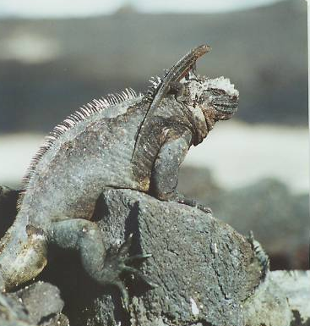
Each island had iguanas in large numbers, yet they were different on each island. Some were black, some were red, one island had iguanas with both red and green markings, a few were brownish-orange; some ate cactus, others consumed algae off submerged tidal rocks. The islands’ namesake tortoises varied in shape from island to island. At one landing Darwin noted their long necks and sharply-arched shells, and on a nearby island the tortoises had short necks and nearly flat shells. On James Island (also called San Salvador) Darwin counted twenty six species of land birds, all unique, and all incredibly tame.

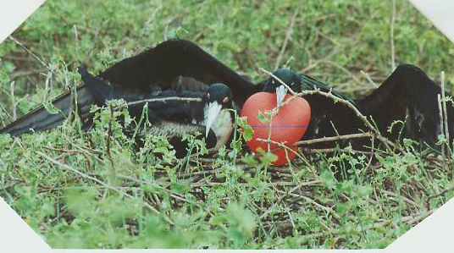
Darwin is perhaps most famous for collecting the Galapagos finches from several of the islands he visited. While all similar in body size and color, their beaks varied in size and shape. To Darwin, it was clear: different foods were available on different islands and through successive generations the birds with the most-useful shaped beak flourished and those with less-useful beak shapes died out. There had to have been a great principle or mechanism involved. While the finches were noted in his journals without much more emphasis than other plant and animal species he collected, many years later they would become one of the biggest arguments in his theory of natural selection.

The Galapagos Islands are spectacular in their topography and contain a stunning variety of rare, unique, approachable, and vanishing species. They are a sparkling jewel to be visited, admired, revered, and protected.

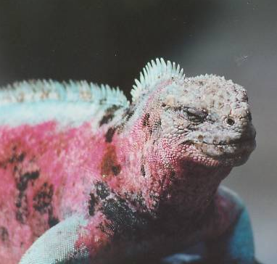
Chronology of the Beagle, 1835
Sept. 15: arrive at the Galapagos Islands

Sept.17: land on Chatham Island

Sept. 23-26: disembark on Charles Island

Sept. 29-Oct. 3: Albemarle Island

Oct. 8-14: James Island

Oct. 20: Survey of Galapagos Archipelago completed, the Beagle
heads towards Tahiti

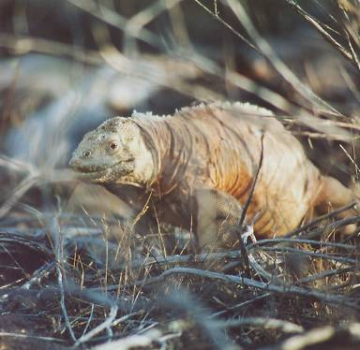
Recommend reading:
The Voyage of the Beagle, Charles Darwin, 1839

Darwin and the Beagle, Alan Moorehead, 1969

The Beak of the Finch, Jonathan Weiner, 1994

Charles Darwin: Voyaging, Janet Browne, 1995

Links:

(To Be Announced)

