Charles Darwin’s Maternal Grandparents
- Josiah Wedgwood I (1730-1795) was the creator of the highly successful Wedgwood Pottery Company. Josiah’s wealth passed to his descendants and some of it eventually became part of the inheritance of Charles Darwin’s wife Emma. This wealth contributed to the estate that made it possible for Charles to pursue his ideas concerning evolution without concern for money.
Smallpox left Josiah Wedgwood I with a permanently weakened knee, which made him unable to work the foot pedal of a potter's wheel. As a result, he concentrated, from an early age, on designing pottery rather than making it with his own labor.
In his early twenties, Wedgwood began working with the most renowned English pottery-maker of his day, Thomas Whieldon. Wedgwood began experimenting with a wide variety of pottery techniques and over the course of the next decade, his experimentation lead to creation of the first true pottery factory. This endeavor was made possible by capital from his marriage to a richly endowed distant cousin, Sarah “Sally” Wedgwood.
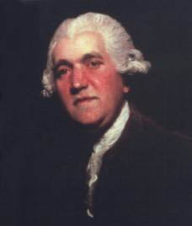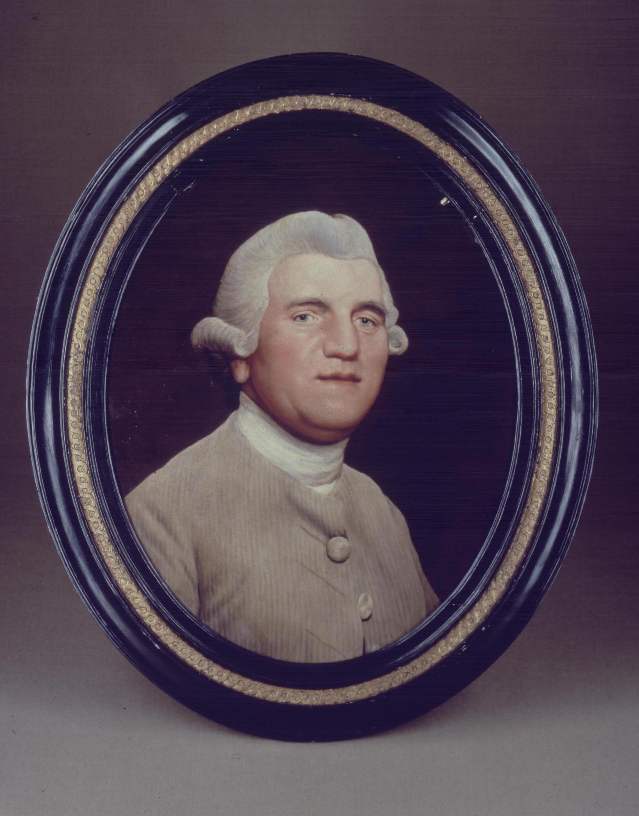
Josiah Wedgwood I
- Sarah Wedgwood (1734-1815) was the daughter of Richard Wedgwood, cheese factor of Spen Green, Cheshire. The couple married in January 1764 at Astbury Church (Cheshire).
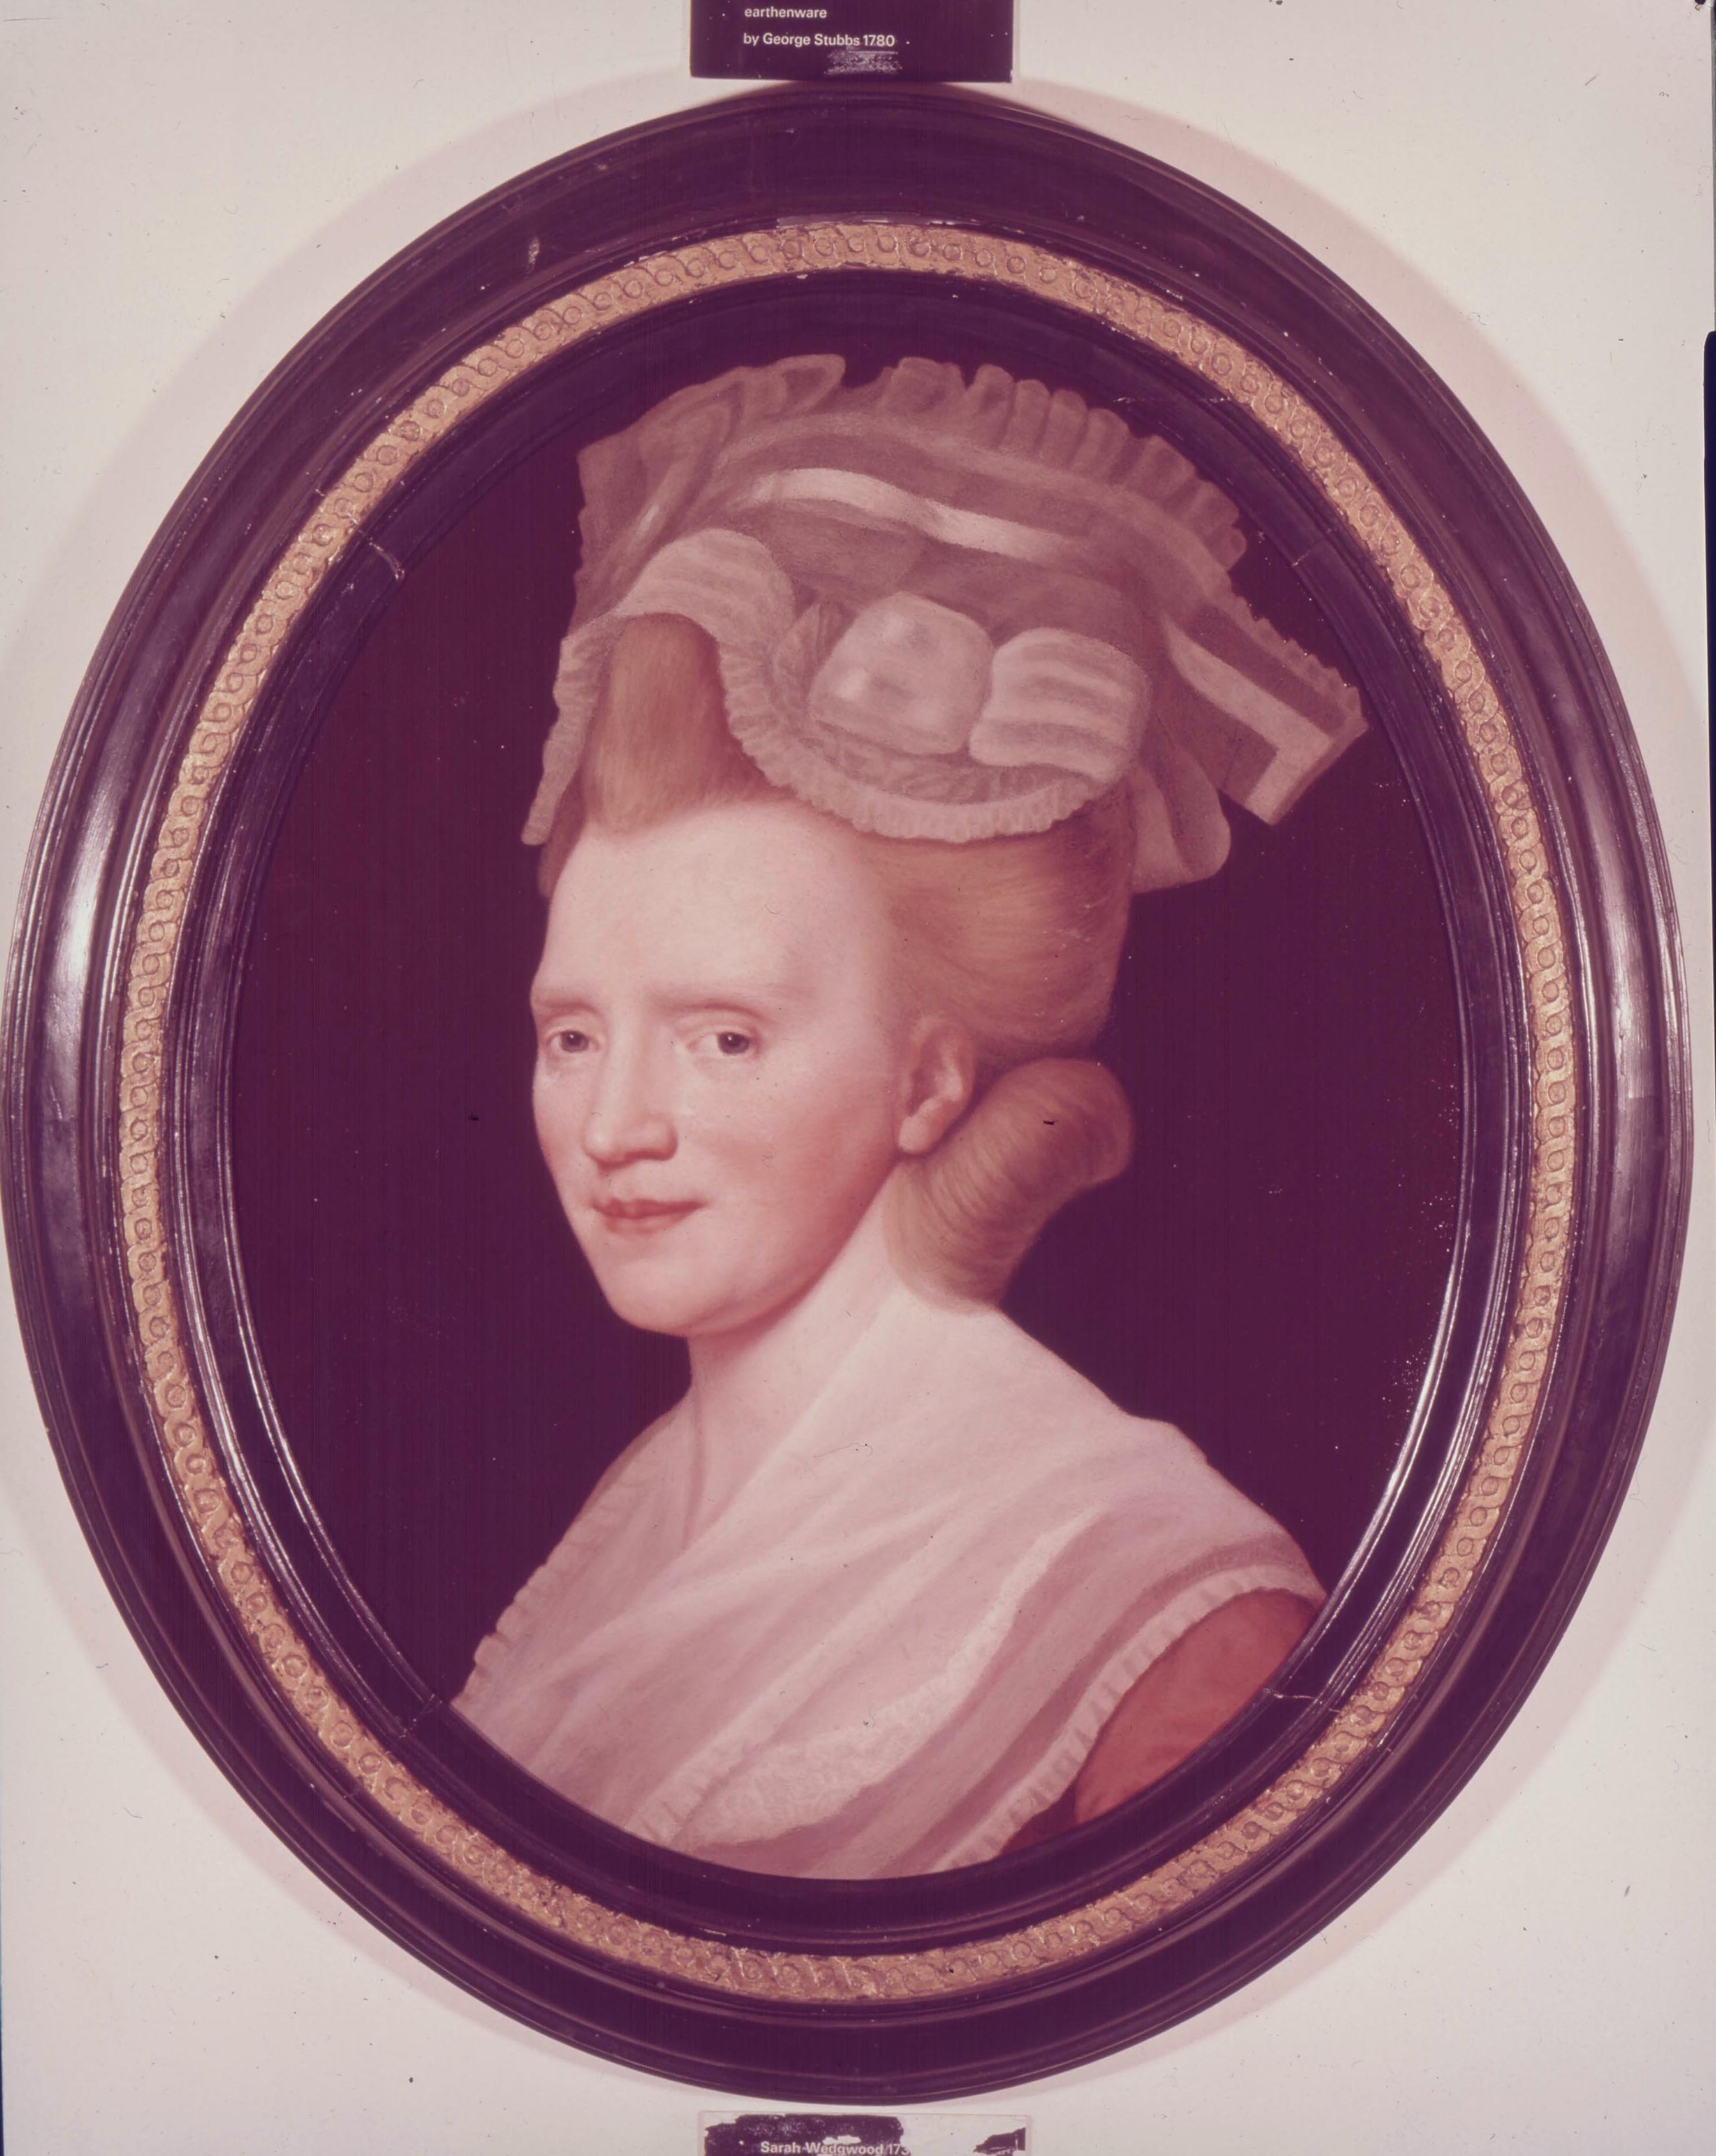
Sarah “Sally” Wedgwood
Josiah cherished his wife whom he called 'Sally', and told his friend Thomas Bentley that she was his 'chief help-mate'. He said that he never finished any of his pots without first asking Sally what she thought of them. Apparently her advice was valuable, because the Wedgwood pottery factory had an uncanny sense of how to market their pottery to their wealthy customers. For instance, the line of pottery first made for Queen Charlotte was named ‘Queen’s Ware’, and was immensely popular and profitable when sold on the mass market.

Josiah and Sarah had a family of seven children: Susannah (Charles Darwin’s mother), John, Josiah II (father to Emma Wedgwood, Charles Darwin’s wife), Thomas, Kitty (Catherine), Sarah, and Mary Anne. Unfortunately a fourth son, named Richard, died when he was very young. The Wedgwood family lived mostly at Maer, about 20 miles North-East of Shrewsbury.

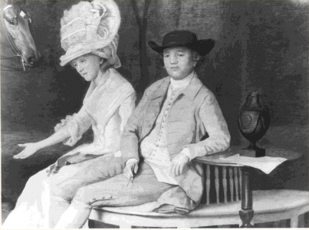

Detail from the ‘Family Portrait’, showing Sarah and Josiah seated under a tree in the grounds of their home, Etruria Hall. Oil on panel, painted by George Stubbs in 1780.

In 1780, Josiah’s long-time business partner Thomas Bentley died, and Wedgwood turned to his friend Erasmus Darwin for help in running the business. Erasmus Darwin and Thomas Wedgwood were both members of the Lunar Society, a discussion club of early English industrialists and scientists. As a result of the close association that grew up between the Wedgwood and Darwin families, one of Josiah's daughters, Susannah, later married Erasmus' son Robert, and they subsequently became the parents of Charles Robert Darwin. Charles Robert would continue the connection between the two families by marrying Emma Wedgwood (daughter of Josiah Wedgwood II), who was a first cousin to Charles. At that time cousin marriage was not prohibited, but Charles Darwin was aware that inbreeding could increase the expression of recessive traits, and he sometimes blamed his marital choice for the illnesses among his children.

Further Reading:

Josiah Wedgwood I

Sarah Wedgwood selection at the Wedgwood Museum family biographies

