Parents of Charles Darwin

- Robert Waring Darwin: 1766 – 1848. Robert Darwin studied medicine at the University of Leyden in Holland and completed his medical studies at Edinburgh, England, in 1786. That autumn he set up as a doctor in Shrewsbury, though he was only 20. His father, Erasmus Darwin, had taken Robert to Shrewsbury and given him 20 pounds to start a medical practice. Erasmus also wrote to friends in Birmingham asking them to recommend Robert to their friends in the Shrewsbury area. Robert was very successful: He was sympathetic and observant and had more than fifty patients within six months. He remained financially successful during sixty years of practice in Shrewsbury. He also served patients over a large area, sometimes traveling by carriage across the border into Wales. He increased his wealth further through real estate speculation, stock and bond investments, and through lending money to the landed gentry.

Standing 6 foot 2 inches tall, and being very portly, “He was an enormous man both physically and in personality. Charles described him as the largest man he had ever seen and compared his return to the family home at the end of the day to the coming in of the tide.”

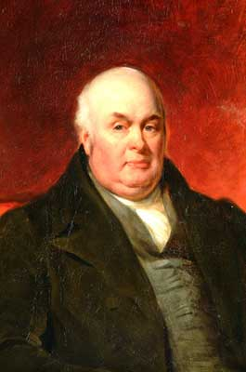

- Susannah Wedgwood: 1765 – 1817. Susannah was the first child of Josiah Wedgwoood I, who had started the highly successful Wedgwood pottery company. Susannah married Robert Darwin in 1796, increasing his wealth by bringing a large dowry. She attended the Unitarian Chapel in Shrewsbury, and due to her influence Charles attended the Unitarian school, operated by Reverend Case, for two years.

From about 1800, Robert and Susannah lived at The Mount, built by Robert Darwin in an elevated position overlooking the town of Shrewsbury:

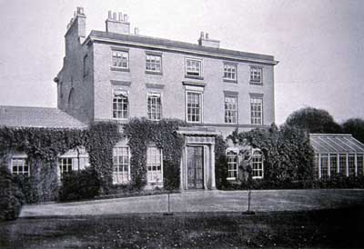
This picture probably represents the Mount much as Charles Darwin knew it. Later photographs show a portico at the front door and, at different periods, different types of greenhouse or conservatory. Robert Darwin was said to enjoy the greenhouse which opened off the morning room. See also the layout diagrams at Plan of the Mount, 1866
Charles Darwin’s mother Susannah died in 1817, when Charles was only 8 years old. He was subsequently raised by his three older sisters.
Further reading:

Shrewsbury: Dr. Robert Darwin
King-Hele, Desmond. Doctor of Revolution: The Life and Genius of Erasmus Darwin. London, Faber & Faber, 1977.
Josiah Wedgwood I

