Saint Chad's Anglican Church and the Dingle Gardens

On November the 15th, 1809, when Charles was only nine months old, he was baptized in Saint Chad's Anglican Church (Fig 9), where his father was a member. The church is situated on one of the highest points in Old Town Shrewsbury and overlooks the wide Water Gardens to the west of the building which now contains the beautiful Dingle Gardens (Fig.10). Only a few churches in England were ever built with round auditoriums and Saint Chad's is one of them. This feature can be seen in figure 11, where the view is from the South across the cemetery at the side of the church. The round sanctuary is to the right in the photograph. Even though Dr. Robert Darwin was a long-time member of this church he and his wife Susannah are buried at -------- Church in ----- about five miles to the (west ?) of the Shrewsbury. When Charles was a boy the place on the water gardens where the Dingle Gardens are now located was a quarry and he recalls going there to collect things from the water (see The Unitarian Church and Reverend Case’s School)
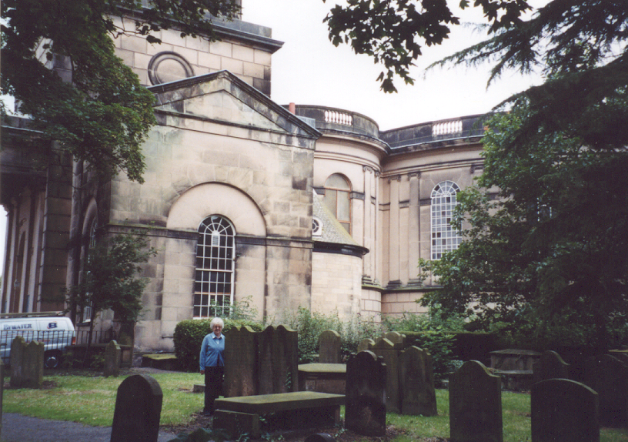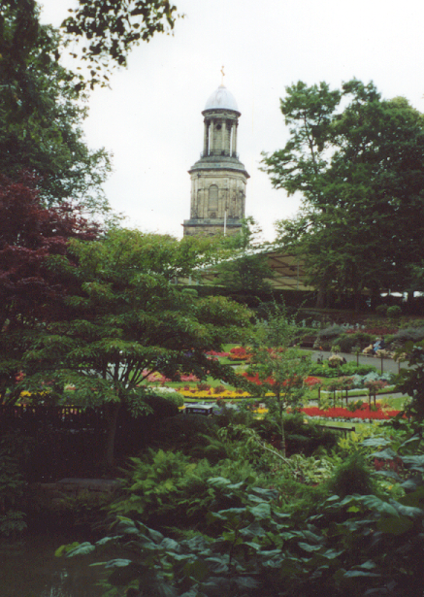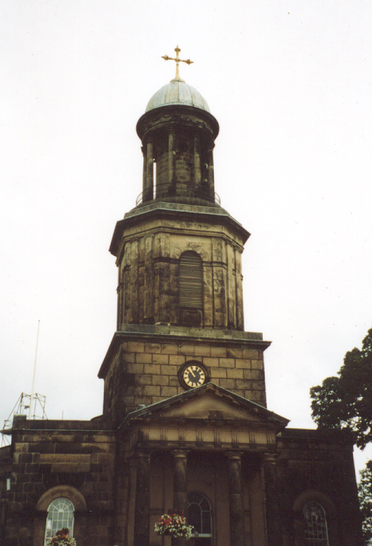

Today the quarry has been transformed into the Dingle Gardens, a sight to behold with brilliant flowerbeds, Figs --&--, walkways, Fig --, and fountains in the center of flowing water, Fig –, all surrounded with beautiful trees Figs --- --- ---. A truly enchanted and romantic place!

