Shrewsbury: Darwin’s Birthplace and Childhood
1809 to 1825

Charles Robert Darwin was born in the town of Shrewsbury, England on February 12th 1809 and this picturesque, well-maintained medieval town is much the same today as it would have been in Darwin's time. The portion of Shrewsbury known as “Old Town” is almost completely surrounded by a horseshoe-shaped bend in the River Severn, as shown in this aerial view of the town below, Fig 1. The English Bridge is to the lower right and the Kingsland Bridge is to the left while the Welsh Bridge is at the center-top of this photograph. In addition there are foot bridges across the river at several points.
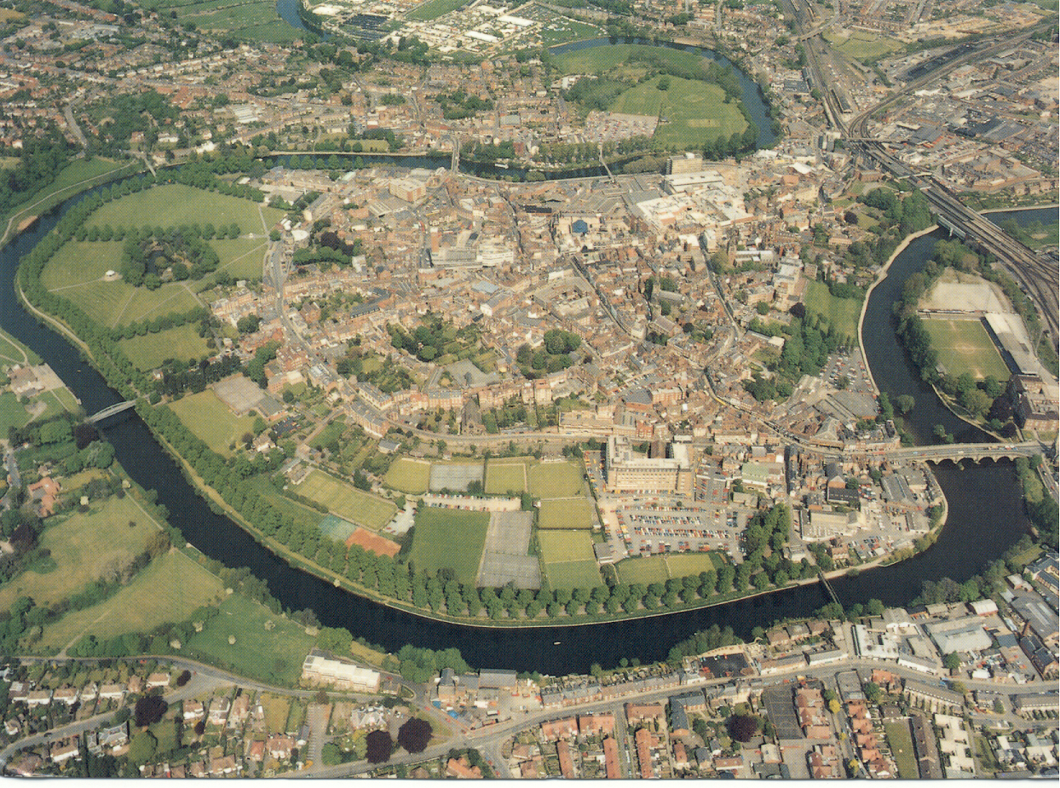
Figure 1. An aerial photograph of Shrewsbury looking north: taken by Aerofilms Ltd.
and published by MU Publishers, Shrewsbury, UK.

The only home that Charles Darwin knew from the time he was born until he returned from his five-year trip around the world on the Beagle at the age of 29, was his family home right here in Shrewsbury. In chronological order, here are the places in Shrewsbury that were important in Darwin's life. We will visit each of these buildings in greater detail below. Darwin was born in the family home, known as The Mount or Mount House, on February 12th, 1809. The home was built by his father, on a bluff overlooking the River Severn, and is located at the top, center-left (A) in figure 1. On November the 15th, 1809, in the same year as he was born, Charles was baptized in Saint Chad's Anglican Church (B). However his mother, the former Susannah Wedgwood, who was a Unitarian, took him as a young child with her to the Unitarian Church on High Street, near the center of town (C). Reverend Case was the minister of the church and also ran an elementary School at 13 Claremont Hill (D), which is close to St. Chad's Church. At the age of eight, Charles was enrolled in Rev. Case's school by his mother but attended this school for only one year. Unfortunately during this year his mother died and he was enrolled at Doctor Samuel Butler's school (E) also known as the Shrewsbury School.

At age 16 his father Robert enrolled him at Edinburgh University and, while Charles would return to the family home as a college student and also returned there after his five-year voyage around the world, he never lived at The Mount permanently again after leaving for Edinburgh.

Other familiar places in Shrewsbury that would have been familiar to Darwin are the Train Station (F), the Shrewsbury Castle (G), and Shrewsbury Abby just over the English Bridge to the right, beyond the edge of the photo. Two additional places that deserved to be mentioned, even though they had not been built in Darwin's time, are the New Shrewsbury secondary school across the Kingsland Bridge and up the hill overlooking the River Severn from the South (H), and the “Darwin” Shopping Center (I) in the middle of town on Castle Street. The campus at the new secondary school is attractive, consisting of a number of handsome redbrick buildings. The reason for mentioning it however is that there is a large statue of Darwin on campus in front of the Administration building. He is depicted as an energetic and active young man on the Galapagos Islands, with iguanas and other creatures around his feet. The Shopping Center is large and modern – an asset to the town that recognizes their most famous son with a month-long “Darwin Festival” which takes place throughout February each year!

