The Unitarian Church and Reverend Case’s School

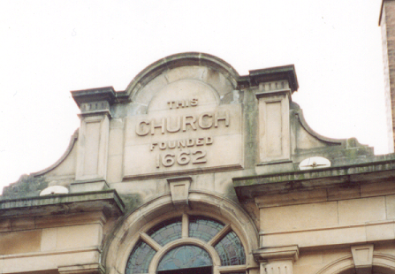
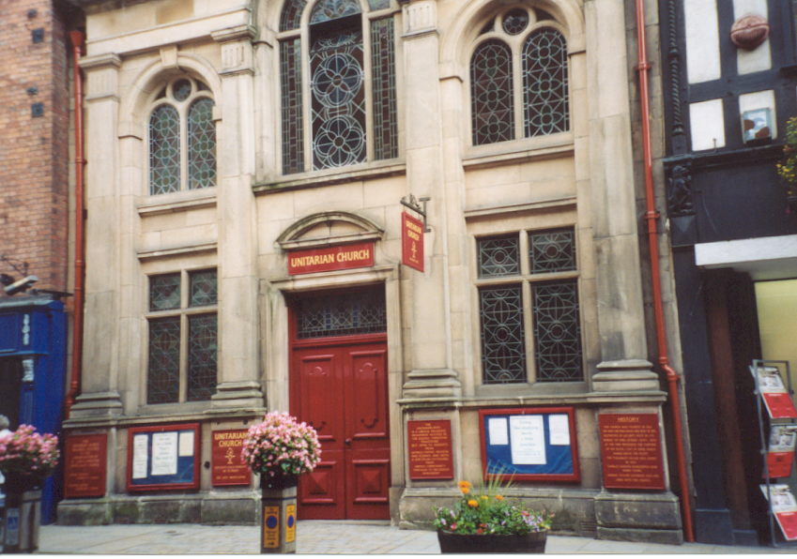
As a young child, his mother, the former Susannah Wedgwood, took Charles to the Unitarian Church Fig.12 and 13 at ----- High Street near the center of town, where she was a member. This attractive building has a plaque commemorating Charles as a member who attended regularly as a youth Fig 14. During this period, Reverend G. Case was the pastor at the Unitarian Church and he also ran a school at 13 Claremont Hill St. Fig.-- next-door to St. Chad’s Church, where Charles was enrolled by his mother in 1816. The view down the hill on Claremont St. across town to the ---- Church would have been a familiar sight to Charles as he came and went from the school. The rear windows of the school looked out onto the cemetery at St. Chad’s church (Fig 15). In his autobiography Charles recalls a number of events during this school year including the dogs in Barker St., newts in the quarry, fruit in the garden, monstrous fables, and the burial of a “dragoon-soldier.”

“ In 1817, when I was 8 ½ years I old attended Mr. Cases School. I remember how very much I was afraid of meeting the dogs in Baker St. and how at school I could not get up my courage to fight. I was very timid by nature. I remember I took great delight at school in fishing for newts in the quarry pool-I had thus young formed a strong taste for collecting, chiefly seals, franks and also pebbles and minerals.”
“About this time, I sometimes store fruit for the sake of eating it; and one of my schemes was ingenious. The kitchen garden was kept locked in the evening, and was surrounded by a high wall, but by the aid of neighboring trees I could easily get on coping. I then fixed a long stick into the hole at the bottom of a rather larger flower-pot, and by dragging this upwards pulled off peaches and plums, which fell into the pot and the prizes were thus secured.”
“One little event during this year has fixed itself very firmly in my mind, and I hope that it has done so from my conscience having been afterwards sorely troubled by it; it is curious as showing that apparently I was interested at this early age in the variability of plants! I told another little boy (I believe it was Leighton, who afterwards became a well-known botanist) that I could produce variously coloured Polyanthus and Primroses by watering them with certain coloured fluids, which was of course a monstrous fable, and had never been tried by me. I may here also confess that as a little boy I was much given to inventing deliberate falsehoods, and this was always done for the sake of causing excitement.”
“I remember clearly only one other incident during the year whilst at Mr. Case’s daily school-namely, the burial of a dragoon-soldier; and it is surprising how clearly I can still see the horse with the man’s empty boot and carbine suspended to the saddle, and the firing over the grave. This scene deeply stirred whatever poetic fancy there was in me.”

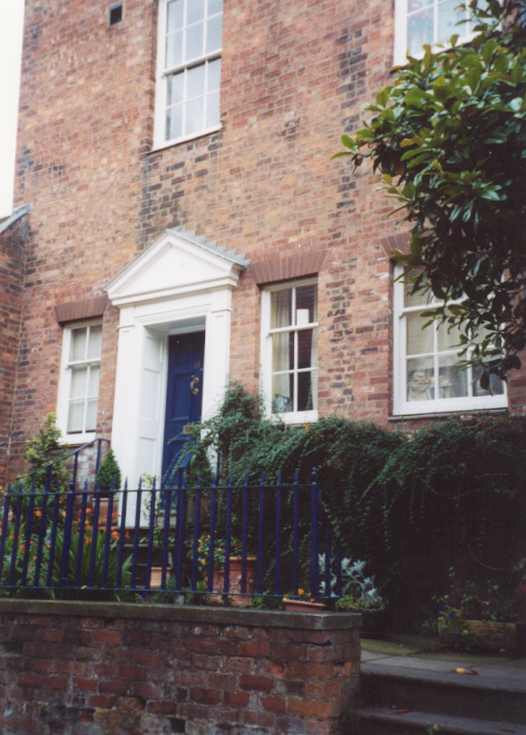
----------------------------------Mr. Case's School, Front Fig 14
--------------------------------Back of Mr. Case's School Fig 15 ------

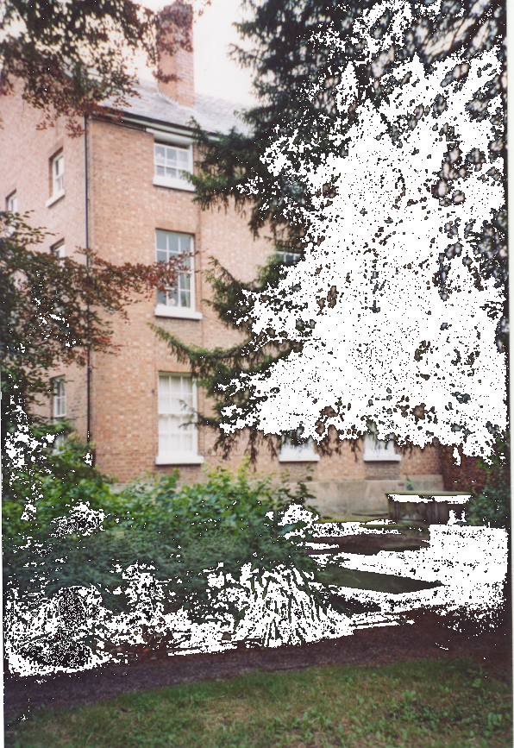
After his mother’s death in July 1817, his older sisters, particularly Caroline continued to take him to the Unitarian Church and to see to his continuing education. However, later that year it was his father who, enrolled him in Doctor Butler's Shrewsbury school.

“My mother died in July 1817, when I was a little over eight years old, and it is odd that I can remember hardly anything about her except her death-bed, her black velvet gown, her curiously constructed work-table and one or two walks with her. I have no distinct remembrances of any conversations, and those only of very trivial nature. I do remember her saying ‘if she did ask me to do something, which I said she had, it was solely for my good.”

