Congratulations to the American Humanist Association on the Occasion of its Sixty-Sixth Annual Conference
From
Darwin Day Celebration
AN INTERNATIONAL RECOGNITION OF SCIENCE AND HUMANITY

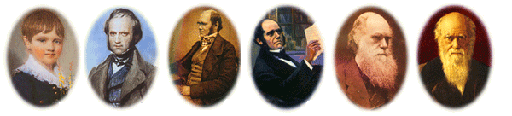
CHARLES ROBERT DARWIN
February 12, 1809 to April 19, 1882

The Evolution of a Global Celebration
Darwin Day wishes to express its sincere appreciation to the American Humanist Association for its cooperation during the past many years regarding our common interest in establishing a National Celebration of Darwin, Science and Humanity. Authentic celebrations provide a tradition and a common bond to be shared among those who understand their significance, permitting them to experience a meaningful connection to one another and to the principles to which they subscribe. Darwin Day Celebration (DDC) maintains that the knowledge system that informs our modern culture is science and that humanism is the most rational philosophy by which to live. Therefore they both deserve to be celebrated!

Like humanism and music, science is an international language that transcends tribalism, sectarianism, fundamentalism, denominationalism and even nationalism. In addition, science provides a paradigm with which we can solve problems within our global community. This paradigm consists of using our very best knowledge system -- verifiable scientific knowledge, together with the postulates of intellectual maturity and rational thought to fairly negotiate international policies and treaties in an all-out effort to lift the nations of the world beyond war.

Finally, DDC encourages the American Humanist Association to provide increased leadership to its many Chapters during the next two years, in cooperation with DDC, so that the Bicentennial of Darwin’s birth on February 12, 2009, can achieve a meaningful, global, dimension. For additional information visit our website at www.DarwinDay.org.

The DDC Board: R. Stephens, A. Jackson, B. Wade, M. White, and R. Siegel
www.DarwinDay.org

