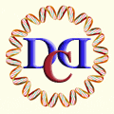 | Darwin Day Celebration  2682 Middlefield Rd, Suite P  Redwood City, CA 94063-3467

Address

