Sincere Appreciation and Congratulations to

Thomas Ferrick for his 30 Years of Exemplary Service as
Humanist Chaplain at Harvard University!
From
Darwin Day Celebration
AN INTERNATIONAL RECOGNITION OF SCIENCE AND HUMANITY

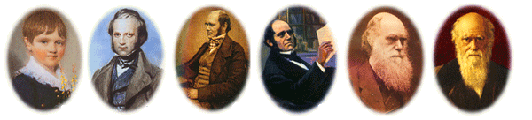
CHARLES ROBERT DARWIN February 12, 1809 to April 19, 1882

The Evolution of a Global Celebration
Celebrations are an important part of every culture. They provide a tradition and a common bond to be shared among those who make up their culture, permitting them to experience a meaningful connection to one another and to the principles to which they subscribe. Darwin Day Celebration (DDC) maintains that the knowledge system that informs our modern culture is science and that humanism is our most rational philosophy by which to live. Therefore they both deserve to be celebrated!

Like humanism and music, science is an international language that transcends tribalism, sectarianism, fundamentalism, denominationalism and even nationalism, and provides a paradigm with which we can solve problems within our global community. This paradigm consists of verifiable scientific knowledge, together with the postulates of intellectual maturity and rational thought.

DDC’s long-term goal is to establish a NEW INTERNATIONAL TRADITION, a SECULAR TRADITION that celebrates SCIENCE AND HUMANITY. A great way to extend Tom Ferrick’s legacy at Harvard would be for each organization and individual, who is taking part in this conference, to sponsor an annual event in Tom’s honor and join DDC in our quest to realize this vision. For assistance go to www.DarwinDay.org.

Finally, the bicentennial of Darwin’s birth on February 12, 2009, provides a splendid opportunity for citizens of the world to permanently commit to an annual Celebration of Darwin, Science and Humanity in recognition of the rights, freedoms and fair treatment of all humans, and to a greater respect and appreciation for all life on this planet.

The DDC Board: R. Stephens; A. Jackson; B. Wade; M. White and R. Siegel

