 | “If the misery of the poor be caused not by the laws of nature, but by our institutions, great is our sin.”  - Charles Darwin  Celebrate Science and Humanity at DarwinDay.org

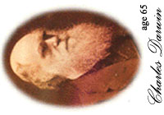 | “In the long history of humankind (and animal kind, too) those who learned to collaborate and improvise most effectively have prevailed.”  - Charles Darwin  Celebrate Science and Humanity at DarwinDay.org

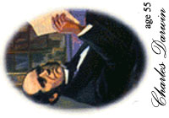 | “Believing as I do that man in the distant future will be a far more perfect creature than he now is, it is an intolerable thought that he and all other sentient beings are doomed to complete annihilation after such long-continued slow progress.”  - Charles Darwin  Celebrate Science and Humanity at DarwinDay.org

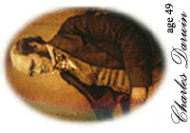 | “I have called this principle, by which each slight variation, if useful, is preserved, by the term Natural Selection.”  - Charles Darwin  Celebrate Science and Humanity at DarwinDay.org

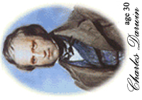

“False facts are highly injurious to the progress of science, for they often endure long; but false views, if supported by some evidence, do little harm, for every one takes a salutary pleasure in proving their falseness..”
- Charles Darwin
Celebrate Science and Humanity at DarwinDay.org

 | “At an early age I sometimes stole fruit for the sake of eating it; and one of my schemes was ingenious. The kitchen garden was kept locked in the evening, and was surrounded by a high wall, but by the aid of neighbouring trees I could easily get on the coping. I then fixed a long stick into the hole at the bottom of a rather large flower-pot, and by dragging this upwards pulled off peaches and plums, which fell into the pot and the prizes were thus secured.”  - Charles Darwin  Celebrate Science and Humanity at DarwinDay.org

