Darwin and Supporters
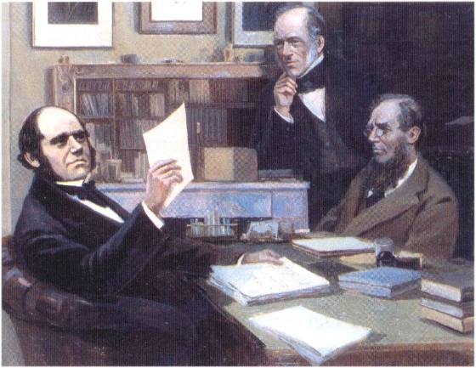
Darwin Lyell Hooker
Among Darwin’s closest friends and supporters were Lyell, Hooker, and Huxley, and they fiercely defended his theory of evolution!

DARWIN DAY IS FOR ONE AND ALL

Darwin Day celebrates Charles Darwin – along with the great minds throughout history – whose explorations and discoveries have led to a new understanding of our world. Modern Science has produced a verifiable knowledge base with which to build a global civilization – and a fulfilling lifetime of excitement and wonder.
JOIN US
Darwin Day invites you to develop your own EVENTS, from grand community celebrations to educational symposia – office parties, birthday parties, gardening, arts and crafts, fun and games, and intimate gatherings with friends – activities are of all sorts. Science organizations, academic societies, activist groups, teachers and students, families and friends – participants represent all walks of life. In Darwin Day, we are able to recognize the diversity among us, while celebrating our common humanity and the universal understanding we share.

Contact Us at …
http://www.DarwinDay.org
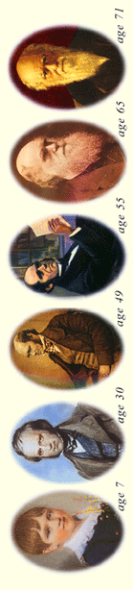
Register your yearly Darwin Day EVENTS on
DarwinDay.org


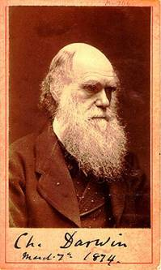
Darwin Day
Bicentennial
Celebration
February 12, 2009
An International Recognition
of Science & Humanity
Every Year since 1995

Evolve Your Own Bicentennial Celebration and register your EVENTS on DarwinDay.org

Charles Robert Darwin was born on February 12, 1809. At age 22 he began a five-year voyage around the world on the Beagle, collecting specimens. Then he began his life’s work on evolution.

A ‘THEORY BY WHICH TO WORK’
In July 1837 Darwin secretly opened his first notebook on the transmutation of species (later to be called evolution) and began to write down his ideas, testing out the theory of progressive change. At this time he had not thought of natural selection. He sketched an irregularly branching tree to illustrate his idea of a family history for the animals, with the trunk symbolizing their common ancestry.

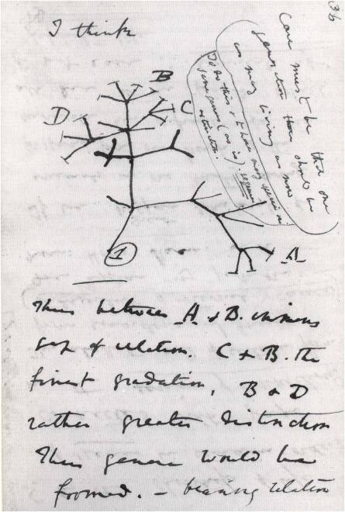
A page from Darwin’s notebook

In September 1838 Darwin read Malthus’ book Essay on the Principles of Populations. Its implications for his own theory made a powerful impact on him, and, nearly forty years later, in his autobiography he wrote that “being well prepared to appreciate the struggle for existence which everywhere goes on from long continued observation of the habits of animals and plants, it at once struck me that under these circumstances favorable variations would tend to be preserved and unfavorable ones destroyed. The results of this would be the formulation of new species. Here, then, I had at last got a theory by which to work.”

Darwin developed the science supporting this theory for the next 20 years before publishing it.

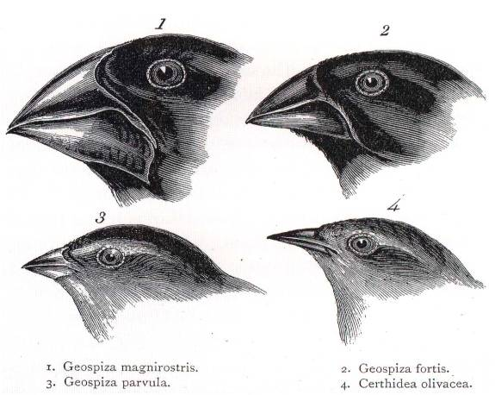

A drawing of the Galapagos finches by John Gould, showing the differences in their beaks.

THE ‘THEORY’ IS PUBLISHED
The manuscript was eventually finished in mid-March 1859, and Darwin took Lyell’s advice to approach John Murray to publish the book. Murray agreed even before he had seen the manuscript. Darwin’s closest friends read and commented upon the draft manuscript. The title was settled and On the Origin of Species by means of Natural Selection was published in November 1859. All copies were sold on the day it was released!

DARWIN’S INFLUENCE ON

MODERN THOUGHT
By Ernst Mayr
Scientific American, July 2000

“Darwin’s accomplishments were so many and so diverse that it is useful to distinguish three fields to which he made major contributions: evolutionary biology, the philosophy of science, and the modern zeitgeist.” Mayr goes on to describe how Darwin established “A secular view of life” and under the heading of Darwinian Zeitgeist, Mayr provides further evidence of Darwin’s influence on modern life. Our worldview has changed dramatically as a result of Darwin’s work.

Down House

A rear view of Darwin’s home from the garden

Few properties can claim to have been as central to the life and work of their owners as Down House. Charles Darwin and his family lived here in comparative seclusion for forty years during which time he wrote the majority of his major works including the most famous, On the Origin of Species and the Decent of Man. In addition he wrote approximately 16,000 letters to hundreds of fellow scientists and friends. These letters are currently being compiled into over 30 volumes at Cambridge University.

