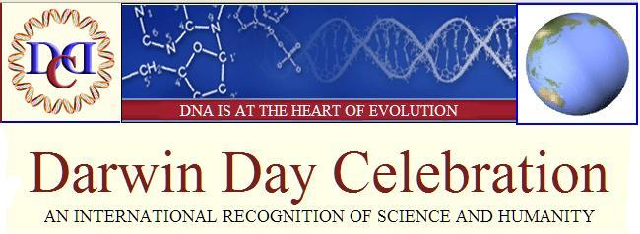

"In the long history of humankind (and animal kind too) those who learned to collaborate and improvise most effectively have prevailed."
- Charles Darwin

DARWIN DAY 2008:

WE ARE ALL SCIENTISTS - A DARWIN DAY THEME?
In his 1863 essay, We are all Scientists, Thomas Aldous Huxley begins:
"There is a well-known incident in one of Moliere's plays, when the author makes the hero express unbounded delight on being told that he had been talking prose during the whole of his life. In the same way I trust that you will take comfort, and be delighted with yourselves, on the discovery that you have been acting …as a scientific man."
Huxley goes on to prove that "we are all scientists" by the way we ascertain that small green apples are sour. "A very trivial circumstance will serve to exemplify this," Huxley writes.
"Suppose you go into a fruiterer's shop, wanting an apple—you take up one, and, on biting it, you find it sour; you look at it, and see that it is hard and green. You take up another one, and that too is hard, green, and sour. The shopman offers you a third; but, before biting it, you examine it, and find that it is hard and green, and you immediately say that you will not have it, as it must be sour, like that you have already tried."
In this same delightful essay Huxley demonstrates how we participate in scientifically solving "the case of the missing teapot and spoons." See http://www.is.wayne.edu/mnissani/a&s/allsci.htm for the entire essay.
Yes, as Huxley says, we are all active scientists, and we all depend on and benefit from the scientific underpinnings of our lives.
Here's the question the Darwin Day Celebration Committee asks you:
Do you think that the theme "We Are All Scientists" is a good theme for Darwin Day 2008?
Some subsets of that question include:
- Do you think this theme creates support for Science?
- Is having a theme helpful in expanding participation in Darwin Day?
- How might you utilize this theme?
Your feedback would be appreciated. To answer click on submit.

EVOLVING EVOLUTION—EVOLUTION IN THE NEWS
For those of you interested in Evolution and or Science we recommend visiting http://www.sciencedaily.com or specifically ScienceDaily: Evolution News

A DARWIN DAY CELEBRATION IS:
a truly international Celebration to express gratitude for the enormous benefits that scientific knowledge, acquired through human curiosity and ingenuity, has contributed to the advancement of humanity. Darwin Day is the only day that celebrates Science.
On Darwin Day, institutions worldwide, including municipalities, public and private schools, colleges and universities, libraries, museums, churches, private organizations and individuals have celebrated Science and Humanity on, or near, Darwin's Birthday, on February 12. In 2007, some 850 separate celebrations (that we know of!) took place.
The goal in 2008 is to make everyone aware of Darwin Day, so that in 2009 we can stage an international Darwin Day extravaganza. The year 2009 is both the anniversary of Darwin's 200th birthday, and the 150th birthday of the Origin of Species in which evolution was introduced.
For information on Darwin and Darwin Day Celebrations, see DarwinDay.org
We hope you will all initiate events and participate in the expansion of this most important day.

DARWIN DAY CELEBRATIONS - TO RECOGNIZE SCIENCE
On Darwin Day, people of all ages and backgrounds can take time to marvel at the complexity and commonalities of all life.
We can take time to observe something in our neighborhood, on our way to school, or work, or church, we haven't noticed before—and think about how it functions or comes into being.
We can organize exhibits and lectures on Science in general and on evolution in particular.
And we can discover the scientist in each of us.
See examples of Darwin Day projects at Darwin Day Celebration, or go to your search engine (such as Google) and search for "Darwin Day."

WHO'S WHO—The Darwin Day Celebration is advised by the following and renowned leaders of the scientific community, including Nobel laureates.
Patrick Bateson | 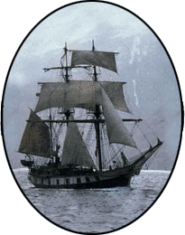  HMS Beagle | Steven Pinker
Provost, Cambridge Univ. |  | Harvard University
William H. Calvin |  | Eugenie C. Scott
Univ. of Washington |  | National Ctr. for Science Ed.
Helena Cronin |  | Michael Shermer
London School of Econ. |  | Cal. Inst.of Technology
Richard Dawkins |  | Frank Sulloway
Oxford University |  | Univ. of California, Berkeley
Daniel C. Dennett |  | Univ. of California, Berkeley
Daniel C. Dennett |  | Colin Tudge
Tufts University |  | Colin Tudge
Tufts University |  | London School of Econ.
William Durham |  | London School of Econ.
William Durham |  | Edward O. Wilson
Stanford University |  | Edward O. Wilson
Stanford University |  | Harvard University
Steve Jones |  | Harvard University
Steve Jones |  | Carl Zimmer
University College London |  | Carl Zimmer
University College London |  | Science Writer
Robin McKie |  | Science Writer
London Observer

